VISUALIZING HOUSING MARKET TRENDS REPORT

- INTRODUCTION

  - Project Overview :
This project analyzes housing market trends using interactive Tableau dashboards to visualize sale prices across different years, neighborhoods, property sizes, and bedroom counts. The dashboard provides a clear and intuitive view of pricing patterns and key factors influencing house values.
  - Purpose :
The purpose of this project is to help users understand how various property features impact housing prices and identify market trends over time. It enables data-driven decision-making for buyers, sellers, and analysts through visual insights.

- IDEATION PHASE

2.1 Problem Statement :
Understanding housing price variations is challenging due to the influence of multiple factors such as location, size, and time. There is a need for an interactive visualization system to analyze these factors and identify meaningful pricing trends.
2.2 Empathy Map Canvas :
The empathy map focuses on users such as buyers, sellers, and analysts who need clear insights into housing prices and market behavior. It captures what users see, think, feel, and need while exploring property data through interactive dashboards.
2.3 Brainstorming:
Brainstorming involved identifying key housing features like neighborhood, sale year, living area, and bedrooms that affect prices. Various chart types and filters were explored to present insights in a simple and interactive manner.

- REQUIREMENT ANALYSIs

3.1 Customer Journey Map :
The user starts by accessing the dashboard to explore housing market data and applies filters such as year, neighborhood, and bedrooms. The journey ends with users gaining insights into pricing trends to support better decision-making.
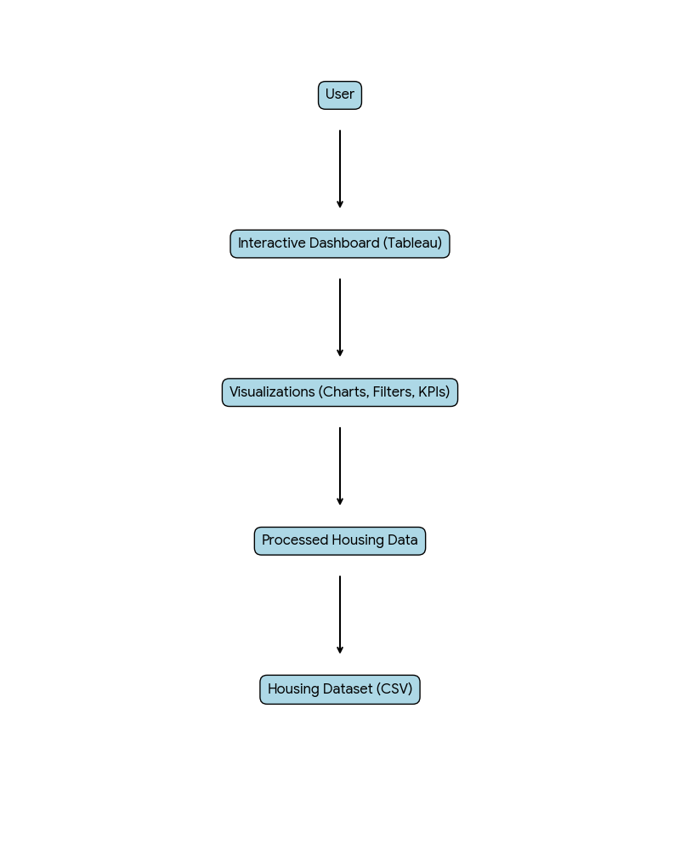

3.2 Solution Requirement :
The solution requires a clean housing dataset, interactive visualizations, and filters to analyze sale prices and property features. It should provide an easy-to-use dashboard that helps users understand trends and comparisons effectively.

3.3 Data Flow Diagram :
The data flow diagram illustrates how housing data is collected, processed, and visualized through Tableau dashboards. It shows the movement of data from the dataset to the final interactive dashboard viewed by users.

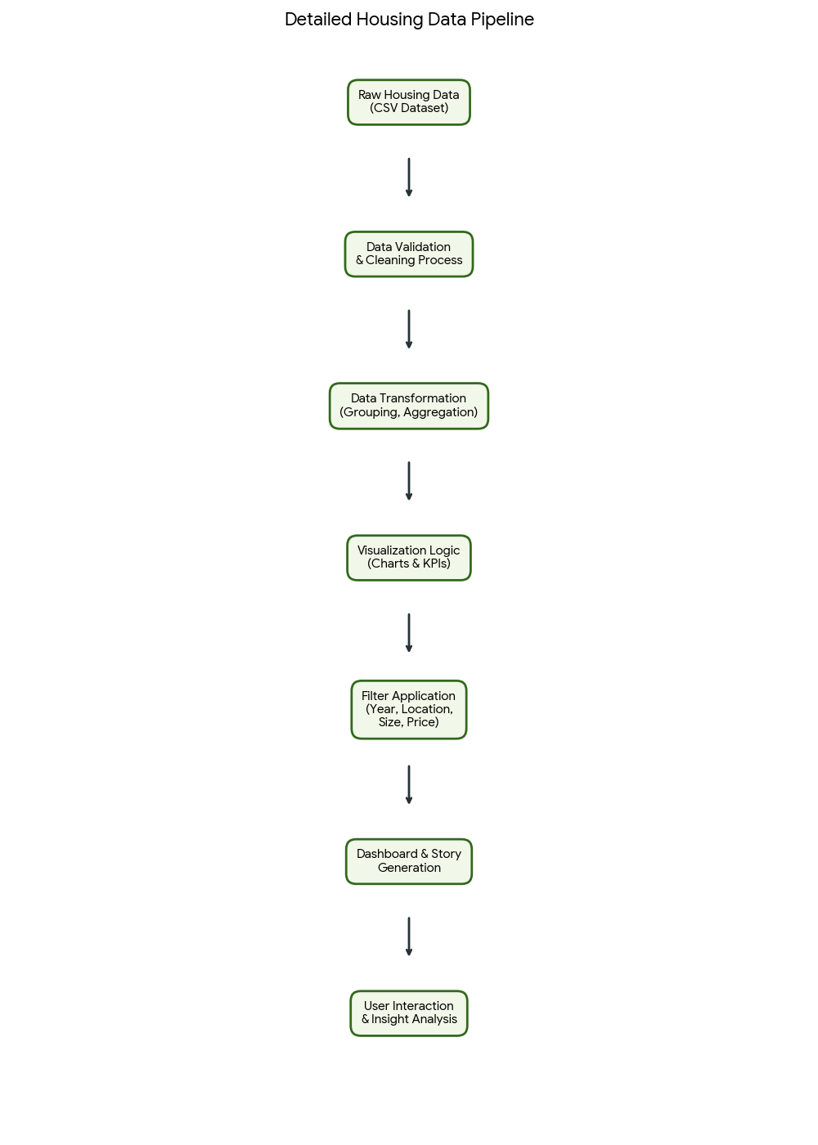

3.4 Technology Stack :
The project uses CSV housing data as input, Tableau for data visualization and dashboard creation, and basic UI components for presentation. Optional web integration can be done using Flask and HTML for embedding dashboards.

- PROJECT DESIGN

4.1 Problem Solution Fit :
The proposed solution effectively addresses the challenge of understanding housing price variations by visualizing key factors such as location, area, and time. Interactive dashboards make complex data easier to analyze and interpret.

4.2 Proposed Solution :
The solution provides an interactive Tableau dashboard that visualizes housing market trends using sale prices and property features. Users can apply filters and explore patterns to gain meaningful insights for decision-making.

4.3 Solution Architecture :
The architecture consists of a housing dataset processed in Tableau to generate visualizations and dashboards. The final output is an interactive dashboard that allows users to analyze housing market trends efficiently.

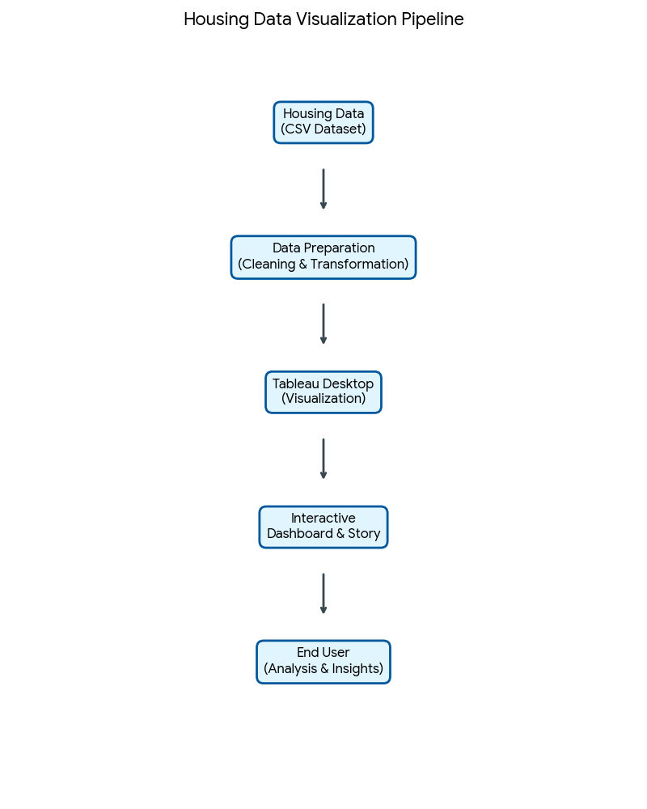

- PROJECT PLANNING & SCHEDULING

  - Project Planning :
The project was planned by dividing tasks into data understanding, visualization development, dashboard creation, and documentation. A structured schedule was followed to complete each phase on time and ensure smooth project execution.

- FUNCTIONAL AND PERFORMANCE TESTING

  - Performance Testing :
Performance testing was conducted to ensure that the Tableau dashboards load quickly and respond smoothly to user interactions. Filters and visualizations were tested to verify efficient performance without delays while handling the dataset.

- RESULTS

The interactive Tableau dashboard successfully revealed housing market trends based on sale prices and key property features. Users were able to compare patterns across years and locations, enabling clear and data-driven insights.

  - Output Screenshots :

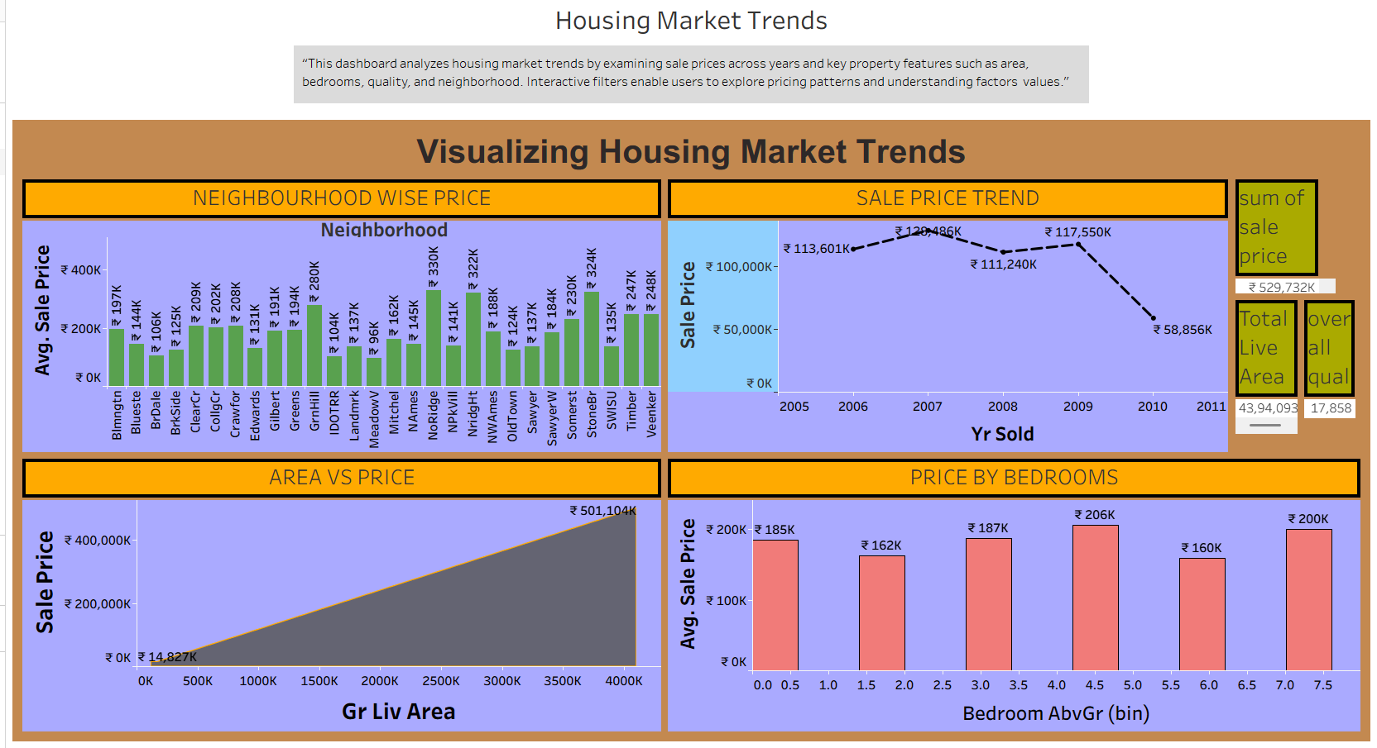
8.ADVANTAGES & DISADVANTAGES

8.1 Advantages :
• Provides interactive visualizations that make complex housing market data easy to understand.
• Helps users identify price trends and key factors influencing property values for better decision-making.
8.2 Disadvantages :
• The analysis depends on historical data and may not reflect real-time market changes.
• Limited insights may occur if important external factors like economic conditions are not included in the dataset.

- CONCLUSION

The project effectively visualizes housing market trends using interactive Tableau dashboards, making complex data easy to interpret. It enables users to gain valuable insights into pricing patterns and factors influencing the housing market.

- FUTURE SCOPE

A) The project can be enhanced by integrating real-time housing market data for more up-to-date analysis.
B) Advanced analytics and predictive models can be added to forecast future housing price trends.
11. APPENDIX

Dataset Link : https://www.kaggle.com/datasets/prevek18/ames-housing-dataset
GitHub Link : https://github.com/Chandhana1234/Visualizing-Housing-Market-Trends/tree/main
Project Demo Link : https://github.com/Chandhana1234/Visualizing-Housing-Market- Trends/blob/main/video%20demonstration%20for%20project.mp4

